**S.02.01.02**

**Balance sheet**

|  |  |
| --- | --- |
|  | **Solvency II value** |
| **C0010** |
| **R0030** | - |
| **R0040** | - 0,00 |
| **R0050** | - |
| **R0060** | 292.031.803,00 |
| **R0070** | **42.790.866.900,00** |
| **R0080** | 1.162.223.165,00 |
| **R0090** | 114.007.171,00 |
| **R0100** | **3.707.587.335,00** |
| R0110 | 1.617.073.411,00 |
| R0120 | 2.090.513.924,00 |
| **R0130** | **33.964.041.949,00** |
| R0140 | 25.936.329.905,00 |
| R0150 | 7.415.946.631,00 |
| R0160 | 131.164.276,00 |
| R0170 | 480.601.137,00 |
| R0180 | 3.255.243.930,00 |
| R0190 | 587.763.350,00 |
| R0200 | - |
| R0210 | - |
| R0220 | 1.706.341.739,00 |
| **R0230** | **2.858.795.637,00** |
| R0240 | 311.226.120,00 |
| R0250 | 178.430.127,00 |
| R0260 | 2.369.139.390,00 |
| **R0270** | **282.806.149,00** |
| **R0280** | 218.778.621,00 |
| **R0290** | 182.740.425,00 |
| **R0300** | 36.038.196,00 |
| **R0310** | 64.027.528,00 |
| **R0320** | 1.492.313,00 |
| **R0330** | 62.535.215,00 |
| **R0340** | - |
| **R0350** | 70.595.130,00 |
| **R0360** | 307.302.677,00 |
| **R0370** | 20.237.513,00 |
| **R0380** | 476.342.622,00 |
| **R0390** | - |
| **R0400** | - |
| **R0410** | 1.287.602.822,00 |
| **R0420** | 57.710.302,00 |
| **R0500** | **50.150.633.294,00** |

|  |  |
| --- | --- |
|  | **Solvency II value** |
| **C0010** |
| **R0510** | **3.540.236.121,00** |
| **R0520** | **2.817.815.141,00** |
| **R0530** | - |
| **R0540** | 2.688.017.312,00 |
| **R0550** | 129.797.829,00 |
| **R0560** | **722.420.980,00** |
| **R0570** | - |
| **R0580** | 693.559.834,00 |
| **R0590** | 28.861.146,00 |
| **R0600** | **33.592.851.998,00** |
| **R0610** | **3.098.779.352,00** |
| **R0620** | - |
| **R0630** | 2.963.218.716,00 |
| **R0640** | 135.560.636,00 |
| **R0650** | **30.494.072.646,00** |
| **R0660** | - |
| **R0670** | 30.254.731.996,00 |
| **R0680** | 239.340.650,00 |
| **R0690** | **1.739.290.703,00** |
| **R0700** | - |
| **R0710** | 1.722.970.611,00 |
| **R0720** | 16.320.092,00 |
| **R0740** | - |
| **R0750** | 57.762.928,00 |
| **R0760** | 743.184.008,00 |
| **R0770** | 146.520.468,00 |
| **R0780** | 45.003.844,00 |
| **R0790** | 284.700.478,00 |
| **R0800** | - |
| **R0810** | 5.263.896.063,00 |
| **R0820** | 290.553.176,00 |
| **R0830** | 15.010.906,00 |
| **R0840** | 342.164.076,00 |
| **R0850** | **-** |
| **R0860** | - |
| **R0870** | - |
| **R0880** | 364.763.164,00 |
| **R0900** | **46.425.937.933,00** |

**Annex I S.05.01.02**

**Premiums, claims and expenses by line of business**

|  |  |  |  |  |  |  |  |  |  |  |  |  |  |
| --- | --- | --- | --- | --- | --- | --- | --- | --- | --- | --- | --- | --- | --- |
| in EUR | | Line of Business for: **non-life insurance and reinsurance obligations (direct business and accepted proportional reinsurance)** | | | | | | | | | | | |
| Medical expense insurance | Income protection insurance | Workers' compensation insurance | Motor vehicle liability insurance | Other motor insurance | Marine, aviation and transport insurance | Fire and other damage to property insurance | General liability insurance | Credit and suretyship insurance | Legal expenses insurance | Assistanc e | Miscellaneous financial loss |
| **C0010** | **C0020** | **C0030** | **C0040** | **C0050** | **C0060** | **C0070** | **C0080** | **C0090** | **C0100** | **C0110** | **C0120** |
| **Premiums written** |  |  | | | | | | | | | | | |
| Gross - Direct Business | **R0110** | 116.928.370,00 | 55.029.264,00 | 266.919.418,00 | 427.099.671,00 | 349.911.202,00 | 14.018.801,00 | 553.799.621,00 | 158.777.924,00 | - | 65.940.196,00 | - | 7.239.523,00 |
| Gross - Proportional reinsurance accepted | **R0120** | - | - | - | - | - | - | - | - | - | - | - | - |
| Gross - Non-proportional reinsurance accepted | **R0130** |  |  |  |  |  |  |  |  |  |  |  |  |
| Reinsurers' share | **R0140** | 4.338.525,00 | 603.822,00 | 4.733.600,00 | 15.549.580,00 | 5.691.655,00 | 313,00 | 33.733.453,00 | 6.899.703,00 | - | 102.225,00 | - | 3.558,00 |
| Net | **R0200** | 112.589.845,00 | 54.425.442,00 | 262.185.818,00 | 411.550.091,00 | 344.219.547,00 | 14.018.488,00 | 520.066.168,00 | 151.878.221,00 | - | 65.837.971,00 | - | 7.235.965,00 |
| **Premiums earned** |  |  | | | | | | | | | | | |
| Gross - Direct Business | **R0210** | 117.264.192,00 | 56.246.915,00 | 266.967.674,00 | 429.105.884,00 | 348.759.007,00 | 14.018.801,00 | 552.415.756,00 | 160.037.356,00 | - | 65.604.677,00 | - | 7.482.535,00 |
| Gross - Proportional reinsurance accepted | **R0220** | - | - | - | - | - | - | - | - | - | - | - | - |
| Gross - Non-proportional reinsurance accepted | **R0230** |  |  |  |  |  |  |  |  |  |  |  |  |
| Reinsurers' share | **R0240** | 4.338.525,00 | 603.822,00 | 4.733.735,00 | 15.660.130,00 | 5.692.170,00 | 313,00 | 33.712.602,00 | 7.281.543,00 | - | 102.225,00 | - | 3.558,00 |
| Net | **R0300** | 112.925.667,00 | 55.643.093,00 | 262.233.939,00 | 413.445.754,00 | 343.066.837,00 | 14.018.488,00 | 518.703.154,00 | 152.755.813,00 | - | 65.502.452,00 | - | 7.478.977,00 |
| **Claims incurred** |  |  | | | | | | | | | | | |
| Gross - Direct Business | **R0310** | 97.242.417,00 | 27.254.920,00 | 217.980.151,00 | 313.418.492,00 | 155.156.617,00 | 6.532.387,00 | 238.253.242,00 | 72.245.138,00 | - | 34.452.151,00 | - | 2.972.469,00 |
| Gross - Proportional reinsurance accepted | **R0320** | - | - | - | - | - | - | - | - | - | - | - | - |
| Gross - Non-proportional reinsurance accepted | **R0330** |  |  |  |  |  |  |  |  |  |  |  |  |
| Reinsurers' share | **R0340** | 3.217.978,00 | 45.058,00 | 1.400.884,00 | 8.170.806,00 | 2.124.784,00 | -  145.263,00 | 2.441.495,00 | 1.867.959,00 | - | 30.701,00 | - | -  4.438,00 |
| Net | **R0400** | 94.024.439,00 | 27.209.862,00 | 216.579.267,00 | 305.247.686,00 | 153.031.833,00 | 6.677.650,00 | 235.811.747,00 | 70.377.179,00 | - | 34.421.450,00 | - | 2.976.907,00 |
| **Changes in other technical provisions** |  |  | | | | | | | | | | | |
| Gross - Direct Business | **R0410** | 757.318,00 | - 803.413,00 | 2.450.557,00 | 9.678.419,00 | - 3.764,00 | - | 1.044.976,00 | 3.427.525,00 | - | - | - | - |
| Gross - Proportional reinsurance accepted | **R0420** | - | - | - | - | - | - | - | - | - | - | - | - |
| Gross - Non- proportional reinsurance accepted | **R0430** |  |  |  |  |  |  |  |  |  |  |  |  |
| Reinsurers'share | **R0440** | - | - | - | - | - | - | - | - | - | - | - | - |
| Net | **R0500** | 757.318,00 | - 803.413,00 | 2.450.557,00 | 9.678.419,00 | - 3.764,00 | - | 1.044.976,00 | 3.427.525,00 | - | - | - | - |
| **Expenses incurred** | **R0550** | 14.572.920,00 | 20.728.741,00 | 63.702.091,00 | 180.676.946,00 | 131.077.910,00 | 4.529.655,00 | 245.017.474,00 | 68.602.926,00 | - | 23.200.428,00 | - | 1.229.956,00 |
| **Other expenses** | **R1200** |  |  |  |  |  |  |  |  |  |  |  |  |
| **Total expenses** | **R1300** |

*Annex I S.05.01.02*

*Premiums, claims and expenses by line of business*

|  |  |  |  |  |  |  |
| --- | --- | --- | --- | --- | --- | --- |
| in EUR | | Line of business for:  **accepted non-proportional reinsurance** | | | | Total |
| Health | Casualty | Marine, aviation, transport | Property |
| **C0130** | **C0140** | **C0150** | **C0160** | **C0200** |
| **Premiums written** |  |  | | | | |
| Gross - Direct Business | **R0110** |  |  |  |  | 2.015.663.990,00 |
| Gross - Proportional reinsurance accepted | **R0120** | - |
| Gross - Non-proportional reinsurance accepted | **R0130** | - | - | - | 30.285.802,00 | 30.285.802,00 |
| Reinsurers' share | **R0140** | - | - | - | 2.885.444,00 | 74.541.878,00 |
| Net | **R0200** | - | - | - | 27.400.358,00 | 1.971.407.914,00 |
| **Premiums earned** |  |  | | | | |
| Gross - Direct Business | **R0210** |  |  |  |  | 2.017.902.797,00 |
| Gross - Proportional reinsurance accepted | **R0220** | - |
| Gross - Non-proportional reinsurance accepted | **R0230** | - | - | - | 30.371.074,00 | 30.371.074,00 |
| Reinsurers' share | **R0240** | - | - | - | 2.885.444,00 | 75.014.067,00 |
| Net | **R0300** | - | - | - | 27.485.630,00 | 1.973.259.804,00 |
| **Claims incurred** |  |  | | | | |
| Gross - Direct Business | **R0310** |  |  |  |  | 1.165.507.984,00 |
| Gross - Proportional reinsurance accepted | **R0320** | - |
| Gross - Non-proportional reinsurance accepted | **R0330** | - | 1.209.087,00 | - | 6.605.323,00 | 7.814.410,00 |
| Reinsurers' share | **R0340** | - | - | - | 572.361,00 | 19.722.325,00 |
| Net | **R0400** | - | 1.209.087,00 | - | 6.032.962,00 | 1.153.600.069,00 |
| **Changes in other technical provisions** |  |  | | | | |
| Gross - Direct Business | **R0410** |  |  |  |  | 16.551.618,00 |
| Gross - Proportional reinsurance accepted | **R0420** | - |
| Gross - Non- proportional reinsurance accepted | **R0430** | - | - | - | - | - |
| Reinsurers'share | **R0440** | - | - | - | - | - |
| Net | **R0500** | - | - | - | - | 16.551.618,00 |
| **Expenses incurred** | **R0550** | - | 26.721,00 | - | 4.257.381,00 | 757.623.149,00 |
| **Other expenses** | **R1200** |  |  |  |  | - |
| **Total expenses** | **R1300** | - |

*Annex I S.05.01.02*

*Premiums, claims and expenses by line of business*

|  |  |  |  |  |  |  |  |  |  |  |
| --- | --- | --- | --- | --- | --- | --- | --- | --- | --- | --- |
| in EUR | | Line of Business for: **life insurance obligations** | | | | | | **Life reinsurance obligations** | | Total |
| Health insurance | Insurance with profit participation | Index-linked and unit- linked insurance | Other life insurance | Annuities stemming from non-life insurance contracts and relating to health insurance obligations | Annuities stemming from non-life insurance contracts and relating to insurance obligations other than health insurance obligations | Health reinsurance | Life reinsurance |  |
| **C0210** | **C0220** | **C0230** | **C0240** | **C0250** | **C0260** | **C0270** | **C0280** | **C0300** |
| **Premiums written** |  |  | | | | | | | | |
| Gross | **R1410** | 28.146.260,00 | 1.088.734.337,00 | 123.417.701,00 | 12.045.413,00 | 56.022.088,00 | - | - | 1.858.252,00 | 1.310.224.051,00 |
| Reinsurers' share | **R1420** | 920.653,00 | 12.446.778,00 | - | 210.104,00 | 11.153.268,00 | - | - | 66.491,00 | 24.797.294,00 |
| Net | **R1500** | **27.225.607,00** | **1.076.287.559,00** | **123.417.701,00** | **11.835.309,00** | **44.868.820,00** | **-** | **-** | **1.791.761,00** | **1.285.426.757,00** |
| **Premiums earned** |  |  | | | | | | | | |
| Gross | **R1510** | 28.146.260,00 | 1.088.734.337,00 | 123.417.701,00 | 12.045.413,00 | 55.966.939,00 | - | - | 1.858.252,00 | 1.310.168.902,00 |
| Reinsurers' share | **R1520** | 920.653,00 | 12.446.778,00 | - | 210.104,00 | 11.185.006,00 | - | - | 66.491,00 | 24.829.032,00 |
| Net | **R1600** | **27.225.607,00** | **1.076.287.559,00** | **123.417.701,00** | **11.835.309,00** | **44.781.933,00** | **-** | **-** | **1.791.761,00** | **1.285.339.870,00** |
| **Claims incurred** |  |  | | | | | | | | |
| Gross | **R1610** | 21.688.309,00 | 2.007.050.386,00 | 194.729.645,00 | 3.023.548,00 | 111.002.502,00 | - | - | 5.341.194,00 | 2.342.835.584,00 |
| Reinsurers' share | **R1620** | 603.182,00 | 33.591.917,00 | - | 160.295,00 | 8.637.877,00 | - | - | - | 42.993.271,00 |
| Net | **R1700** | **21.085.127,00** | **1.973.458.469,00** | **194.729.645,00** | **2.863.253,00** | **102.364.625,00** | **-** | **-** | **5.341.194,00** | **2.299.842.313,00** |
| **Changes in other technical provisions** |  |  | | | | | | | | |
| Gross | **R1710** | 962.716,00 | - 430.630.009,00 | - 113.838.607,00 | 1.239.729,00 | - 19.602.365,00 | - | - | - 2.171.920,00 | - 564.040.456,00 |
| Reinsurers' share | **R1720** | - | - 27.347.189,00 | - | - | - | - | - | - | - 27.347.189,00 |
| Net | **R1800** | **962.716,00** | **- 403.282.820,00** | **- 113.838.607,00** | **1.239.729,00** | **- 19.602.365,00** | **-** | **-** | **- 2.171.920,00** | **- 536.693.267,00** |
| **Expenses incurred** | **R1900** | 4.472.596,00 | 169.803.456,00 | 31.668.699,00 | 5.816.979,00 | 15.313.417,00 | - | - | 183.303,00 | 227.258.450,00 |
| **Other expenses** | **R2500** |  |  |  |  |  |  |  |  | 6.981,00 |
| **Total expenses** | **R2600** | 227.265.431,00 |

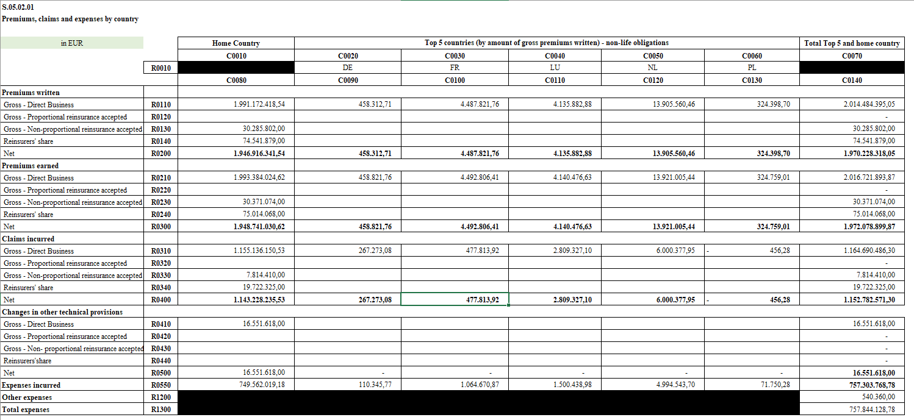

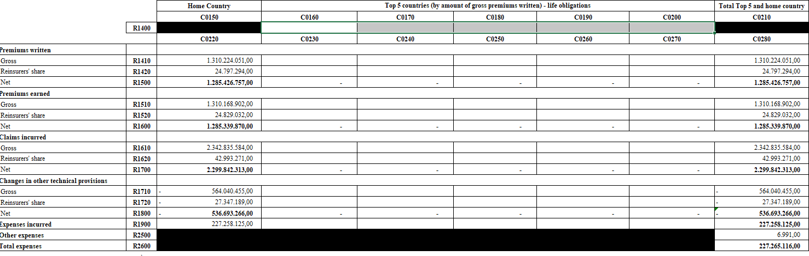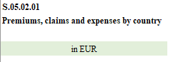

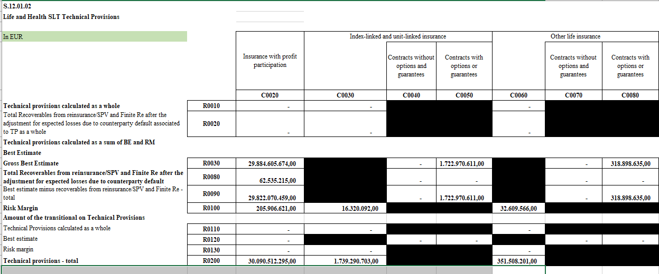

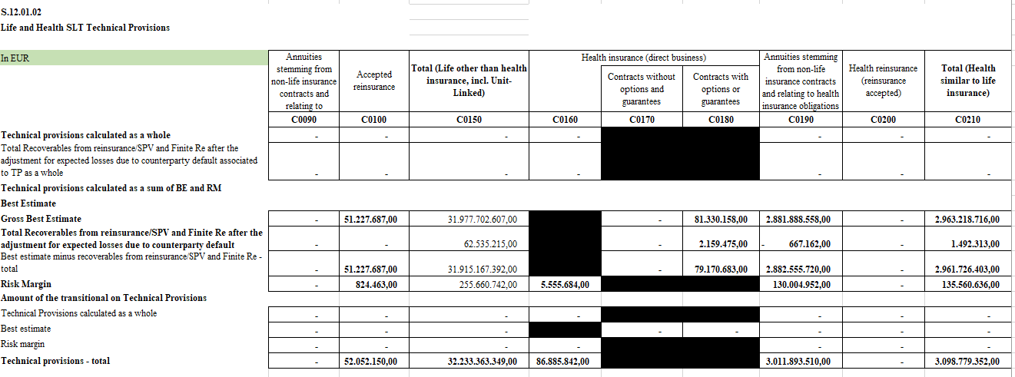

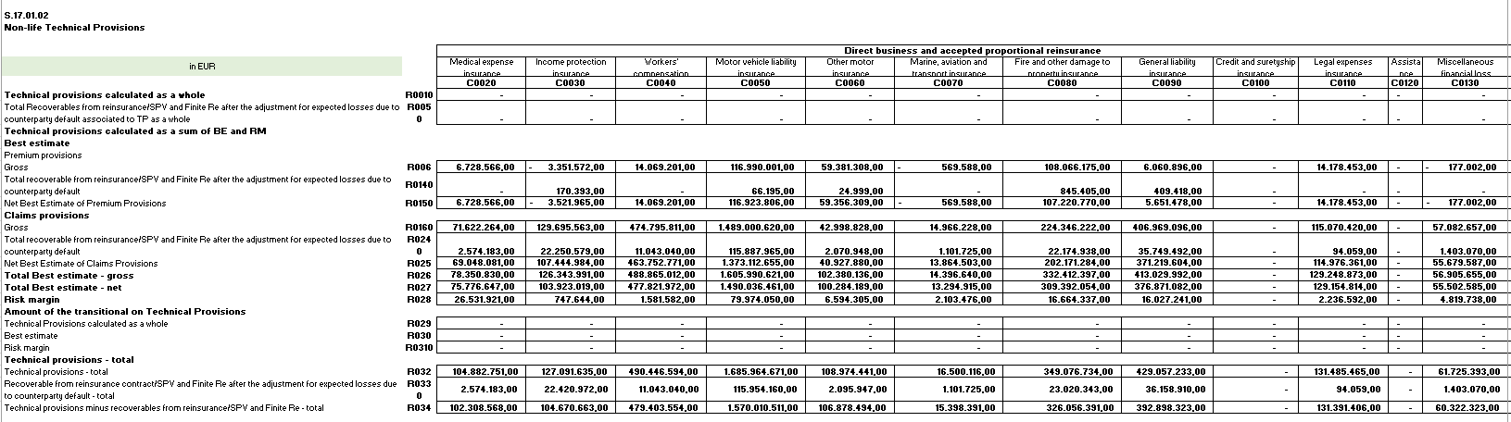

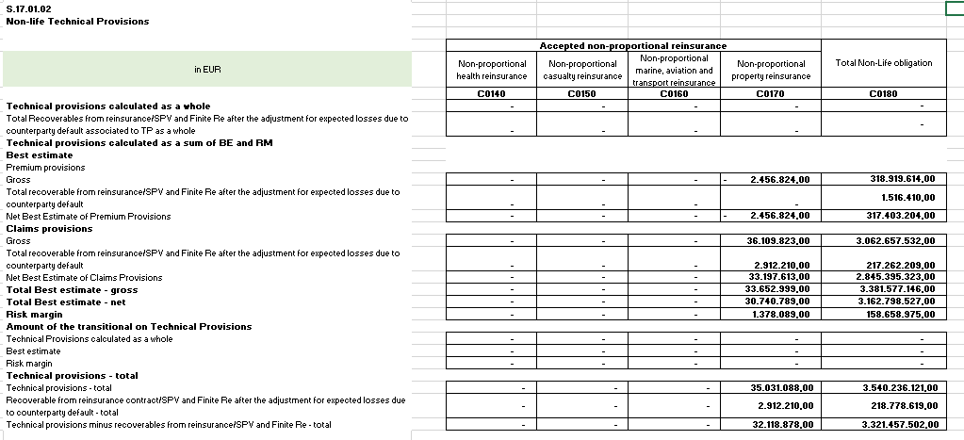

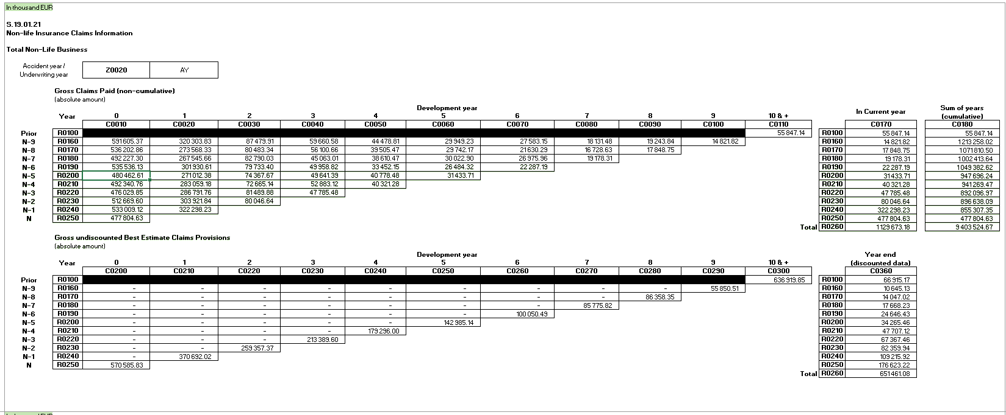

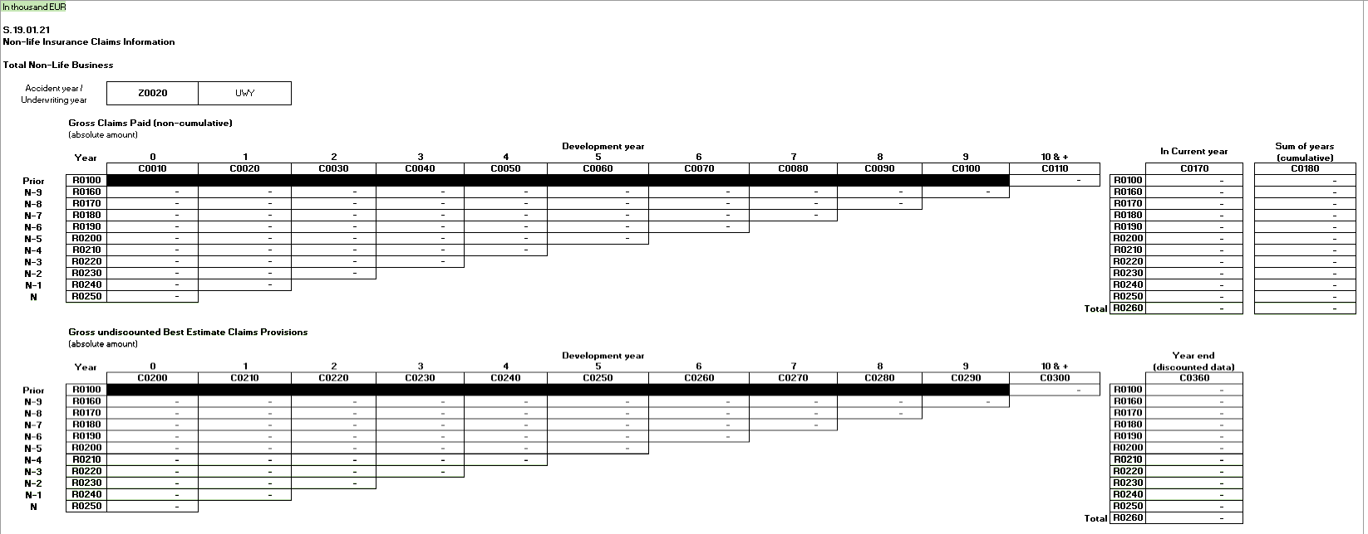

**S.22.01.21**

**Impact of long term guarantees and transitional measures**

|  |  |  |  |  |  |  |
| --- | --- | --- | --- | --- | --- | --- |
| in EUR | | **Amount with Long Term Guarantee measures and transitionals** | **Impact of transitional on technical provisions** | **Impact of transitional on interest rate** | **Impact of volatility adjustment set to zero** | **Impact of matching adjustment set to zero** |
| **C0010** | **C0030** | **C0050** | **C0070** | **C0090** |
| Technical provisions | **R0010** | **38.872.378.822,00** | **-** | **-** | **245.986.202,00** | **-** |
| Basic own funds | **R0020** | **3.393.270.028,00** | **-** | **-** | **- 186.650.521,00** | **-** |
| Eligible own funds to meet Solvency Capital Requirement | **R0050** | **3.393.270.028,00** | **-** | **-** | **- 186.650.521,00** | **-** |
| Solvency Capital Requirement | **R0090** | **1.837.851.706,00** | **-** | **-** | **1.548.108.918,00** | **-** |
| Eligible own funds to meet Minimum Capital Requirement | **R0100** | **3.393.270.028,00** | **-** | **-** | **- 186.650.521,00** | **-** |
| Minimum Capital Requirement | **R0110** | **827.033.267,00** | **-** | **-** | **696.649.013,00** | **-** |

|  |  |  |  |  |  |  |
| --- | --- | --- | --- | --- | --- | --- |
| **S.23.01.01**  **Own funds** |  | | | | | |
|  |  | **Total** | **Tier 1 - unrestricted** | **Tier 1 - restricted** | **Tier 2** | **Tier 3** |
|  |  | **C0010** | **C0020** | **C0030** | **C0040** | **C0050** |
| **Basic own funds before deduction for participations in other financial sector as foreseen in article 68 of Delegated Regulation 2015/35** |  |  |  |  |  |  |
| Ordinary share capital (gross of own shares) | R0010 | 163.363.289,00 | 163.363.289,00 |  |  |  |
| Share premium account related to ordinary share capital | R0030 | 9.138.831,00 | 9.138.831,00 |  |  |  |
| Initial funds, members' contributions or the equivalent  basic own - fund item for mutual and mutual-type undertakings | R0040 |  |  |  |  |  |
| Subordinated mutual member accounts | R0050 |  |  |  |  |  |
| Surplus funds | R0070 | 1.825.000,00 | 1.825.000,00 |  |  |  |
| Preference shares | R0090 |  |  |  |  |  |
| Share premium account related to preference shares | R0110 |  |  |  |  |  |
| Reconciliation reserve | R0130 | 3.218.942.908,00 | 3.218.942.908,00 |  |  |  |
| Subordinated liabilities | R0140 |  |  |  |  |  |
| An amount equal to the value of net deferred tax assets | R0160 |  |  |  |  |  |
| Other own fund items approved by the supervisory authority as basic own funds not specified above | R0180 |  |  |  |  |  |
| **Own funds from the financial statements that should not be represented by the reconciliation reserve and do not meet the criteria to be classified as Solvency II own funds** |  |  |  |  |  |  |
| Own funds from the financial statements that should not be represented by the reconciliation reserve and do not meet the criteria to be classified as Solvency II own funds | R0220 |  |  |  |  |  |
| **Deductions** |  |  |  |  |  |  |
| Deductions for participations in financial and credit  institutions | R0230 |  |  |  |  |  |
| **Total basic own funds after deductions** | R0290 | 3.393.270.028,00 | 3.393.270.028,00 |  |  |  |

**S.23.01.01**

**Own funds**

|  |  |  |  |  |  |  |
| --- | --- | --- | --- | --- | --- | --- |
|  | | **Total** | **Tier 1 - unrestricted** | **Tier 1 - restricted** | **Tier 2** | **Tier 3** |
| **C0010** | **C0020** | **C0030** | **C0040** | **C0050** |
| **Ancillary own funds** |  |  |  |  |  |  |
| Unpaid and uncalled ordinary share capital callable on demand | R0300 |  |  | |  |  |
| Unpaid and uncalled initial funds, members' contributions or the equivalent basic own fund item for mutual and mutual - type undertakings, callable on demand | R0310 |  |  |
| Unpaid and uncalled preference shares callable on demand | R0320 | 0,00 |  |  |
| A legally binding commitment to subscribe and pay for subordinated liabilities on demand | R0330 | 0,00 |  |  |
| Letters of credit and guarantees under Article 96(2) of the Directive 2009/138/EC | R0340 |  |  |  |
| Letters of credit and guarantees other than under Article 96(2) of the Directive 2009/138/EC | R0350 | 0,00 |  |  |
| Supplementary members calls under first subparagraph of Article 96(3) of the Directive 2009/138/EC | R0360 |  |  |  |
| Supplementary members calls - other than under first subparagraph of Article 96(3) of the Directive 2009/138/EC | R0370 | 0,00 |  |  |
| Other ancillary own funds | R0390 | 0,00 |  |  |
| **Total ancillary own funds** | R0400 | 0,00 | 0,00 | 0,00 |

|  |  |  |  |  |  |  |
| --- | --- | --- | --- | --- | --- | --- |
| **Available and eligible own funds** |  |  | | | | |
| **Total available own funds to meet the SCR** | R0500 | 3.393.270.028,00 | 3.393.270.028,00 |  |  |  |
| **Total available own funds to meet the MCR** | R0510 | 3.393.270.028,00 | 3.393.270.028,00 |  |  |  |
| Total eligible own funds to meet the SCR | R0540 | 3.393.270.028,00 | 3.393.270.028,00 |  |  |  |
| Total eligible own funds to meet the MCR | R0550 | 3.393.270.028,00 | 3.393.270.028,00 |  |  |  |
| **SCR** | R0580 | 1.837.851.706,00 |  | | |
| **MCR** | R0600 | 827.033.267,00 |
| **Ratio of Eligible own funds to SCR** | R0620 | 1,85 |
| **Ratio of Eligible own funds to MCR** | R0640 | 4,10 |

**S.23.01.01**

**Own funds**

**Reconciliation reserve**

|  |  |  |
| --- | --- | --- |
|  | | C0060 |
| **Reconciliation reserve** |  |  |
| Excess of assets over liabilities | R0700 | 3.724.695.361,00 |
| Own shares (held directly and indirectly) | R0710 |  |
| Foreseeable dividends, distributions and charges | R0720 | 331.425.333,00 |
| Other basic own fund items | R0730 | 174.327.120,00 |
| Adjustment for restricted own fund items in  respect of matching adjustment portfolios and ring fenced funds | R0740 |  |
| **Reconciliation reserve** | R0760 | 3.218.942.908,00 |
| **Expected profits** |  |  |
| Expected profits included in future premiums (EPIFP) - Life business | R0770 | 122.836.936,00 |
| Expected profits included in future premiums (EPIFP) - Non-life business | R0780 | 12.254.523,00 |
| **Total Expected profits included in future premiums (EPIFP)** | R0790 | 135.091.459,00 |

**Annex I S.25.03.21**

**Solvency Capital Requirement - for undertakings on Full Internal Models**

|  |  |  |
| --- | --- | --- |
| **Unique number of component** | **Components description** | **Calculation of the Solvency Capital Requirement** |

**C0010 C0020 C0030**

|  |  |  |
| --- | --- | --- |
| 1 | Market Risk | 1.303.632.145,31 |
| 2 | Credit Risk | 228.919.673,05 |
| 3 | Life Risk | 491.711.054,96 |
| 4 | P&C Risk | 421.272.459,40 |
| 5 | Operational Risk | 171.696.227,41 |
| 6 | Intangible Risk | 0,00 |
| 7 | LAC Deferred taxes | -45.093.938,57 |
|  |  |  |

**Calculation of Solvency Capital Requirement C0100**

|  |
| --- |
| 2.572.137.621,56 |
| -734.285.916,04 |
|  |
| 1.837.851.705,51 |
| 0,00 |
| 1.837.851.705,51 |
|  |
|  |
| -45.093.938,57 |
|  |
|  |
|  |
|  |
|  |
|  |
|  |

Total undiversified components **R0110**

Diversification **R0060**

Capital requirement for business operated in accordance with Art. 4 of Directive 2003/41/EC (transitional)

**R0160**

**Solvency capital requirement excluding capital add-on R0200**

Capital add-ons already set **R0210**

**Solvency capital requirement R0220**

**Other information on SCR**

Amount/estimate of the overall loss-absorbing capacity of technical provisions **R0300**

Amount/estimate of the overall loss-absorbing capacity ot deferred taxes **R0310**

~~For information only:~~

~~Estimate of loss-absorbing capacity ot technical provisions if modelled within components~~ ~~Estimate of loss-absorbing capacity ot deferred tax if modelled within components~~

Total amount of Notional Solvency Capital Requirements for remaining part **R0410**

Total amount of Notional Solvency Capital Requirements for ring fenced funds (other than

those related to business operated in accordance with Art. 4 of Directive 2003/41/EC (transitional))

**R0420**

Total amount of Notional Solvency Capital Requirement for matching adjustment portfolios **R0430**

Diversification effects due to RFF nSCR aggregation for article 304 **R0440**

**Minimum Capital Requirement - Both life and non-life insurance activity**

**S.28.02.01**

**MCR components**

|  |  |  |  |
| --- | --- | --- | --- |
|  | | **MCR components** | |
| **Non-life activities** | **Life activities** |
| MCR(NL, NL)  Result | MCR(NL,  L)Result |
| C0010 | C0020 |
| **Linear formula component for non-life insurance and reinsurance obligations** | R0010 | 485.515.010,77 | 0,00 |

**Background information**

|  |  |  |  |  |  |
| --- | --- | --- | --- | --- | --- |
|  | | **Background information** | | | |
| **Non-life activities** | | **Life activities** | |
| Net (of reinsurance) best estimate provisions | Net (of reinsurance) written premiums in the last 12  months | Net (of reinsurance) best estimate provisions | Net (of reinsurance) written premiums in the last 12  months |
| C0030 | C0040 | C0050 | C0060 |
| Medical expense insurance and proportional reinsurance | R0020 | 75.776.646,90 | 121.266.893,83 |  |  |
| Income protection insurance and proportional reinsurance | R0030 | 104.590.180,71 | 122.874.444,63 |  |  |
| Workers' compensation insurance and  proportional reinsurance | R0040 | 477.821.972,15 | 271.653.017,80 |  |  |
| Motor vehicle liability insurance and proportional reinsurance | R0050 | 1.490.036.462,46 | 442.649.250,64 |  |  |
| Other motor insurance and proportional reinsurance | R0060 | 100.284.189,49 | 355.602.856,89 |  |  |
| Marine, aviation and transport insurance and  proportional reinsurance | R0070 | 13.295.914,90 | 14.019.113,98 |  |  |
| Fire and other damage to property insurance and proportional reinsurance | R0080 | 309.392.053,70 | 587.533.074,20 |  |  |
| General liability insurance and proportional reinsurance | R0090 | 376.871.082,65 | 165.677.627,22 |  |  |
| Credit and suretyship insurance and proportional reinsurance | R0100 | 0,00 | 0,00 |  |  |
| Legal expenses insurance and proportional reinsurance | R0110 | 129.154.814,44 | 66.042.421,28 |  |  |
| Assistance and proportional reinsurance | R0120 | 0,00 | 0,00 |  |  |
| Miscellaneous financial loss insurance and proportional reinsurance | R0130 | 55.501.581,76 | 7.243.080,91 |  |  |
| Non-proportional health reinsurance | R0140 | 0,00 | 0,00 |  |  |
| Non-proportional casualty reinsurance | R0150 | 0,00 | 0,00 |  |  |
| Non-proportional marine, aviation and transport reinsurance | R0160 | 0,00 | 0,00 |  |  |
| Non-proportional property reinsurance | R0170 | 30.740.788,73 | 33.171.245,83 |  |  |

**Linear formula component for life insurance and reinsurance obligations**

|  |  |  |  |
| --- | --- | --- | --- |
|  | | **Non-life activities** | **Life activities** |
| MCR(L, NL)  Result | MCR(L, L) Result |
| C0070 | C0080 |
| Linear formula component for life insurance or reinsurance obligations | R0200 | 60.519.659,74 | 1.171.921.350,23 |

**Minimum Capital Requirement - Both life and non-life insurance activity**

**S.28.02.01**

**Total capital at risk for all life (re)insurance obligations**

|  |  |  |  |  |  |
| --- | --- | --- | --- | --- | --- |
|  | | **Non-life activities** | | **Life activities** | |
| Net (of reinsurance) best estimate provisions | Net (of reinsurance) capital at risk | Net (of reinsurance) best estimate provisions | Net (of reinsurance) capital at risk |
| C0090 | C0100 | C0110 | C0120 |
| Obligations with profit participation - guaranteed benefits | R0210 | 0,00 |  | 30.827.016.887,06 |  |
| Obligations with profit participation - future discretionary benefits | R0220 | 0,00 | 503.700.619,33 |
| Index-linked and unit-linked insurance obligations | R0230 | 0,00 | 1.622.206.134,03 |
| Other life (re)insurance and health (re)insurance obligations | R0240 | 2.881.888.559,10 | 757.827.334,36 |
| Total capital at risk for all life (re)insurance  obligations | R0250 |  | 0,00 |  | 43.206.200.932,26 |

**Overall MCR calculation**

|  |  |  |
| --- | --- | --- |
|  | | C0130 |
| Linear MCR | R0300 | 1.717.956.020,74 |
| SCR | R0310 | 1.800.741.808,97 |
| MCR cap | R0320 | 810.333.814,03 |
| MCR floor | R0330 | 450.185.452,24 |
| Combined MCR | R0340 | 810.333.814,03 |
| Absolute floor of the MCR | R0350 | 7.400.000,00 |
| **Minimum Capital Requirement** | R0400 | 810.333.814,03 |

**Notional non-life and life MCR calculation**

|  |  |  |  |
| --- | --- | --- | --- |
|  | | **Non-life activities** | **Life activities** |
| C0140 | C0150 |
| Notional linear MCR | R0500 | 546.034.670,51 | 1.171.921.350,23 |
| Notional SCR with add-on (annual or latest calculation) | R0510 | 572.347.282,74 | 1.228.394.526,23 |
| Notional MCR cap | R0520 | 257.556.277,23 | 552.777.536,80 |
| Notional MCR floor | R0530 | 143.086.820,69 | 307.098.631,56 |
| Notional Combined MCR | R0540 | 257.556.277,23 | 552.777.536,80 |
| Absolute floor of the notional MCR | R0550 | 3.700.000,00 | 3.700.000,00 |
| Notional MCR | R0560 | 257.556.277,23 | 552.777.536,80 |